Design document for the   
computer game *Bubble Trouble*

# Game description

In *Bubble Trouble*, the user controls a character on screen with various sized bubbles falling from the top of the screen. The character is armed with a harpoon gun with the objective of bursting all the bubbles on the screen. The player must be careful to avoid any collisions with the bubbles, to avoid losing any lives.

Here are the specifics:

* The player has the ability to only move left and right, at the bottom of the screen
* The player is equipped with three lives. A collision with a bubble will result in the loss of one life
* A score of 10 will be awarded for every bubble popped

# Sketch of the game screen

The game screen will look something like this.

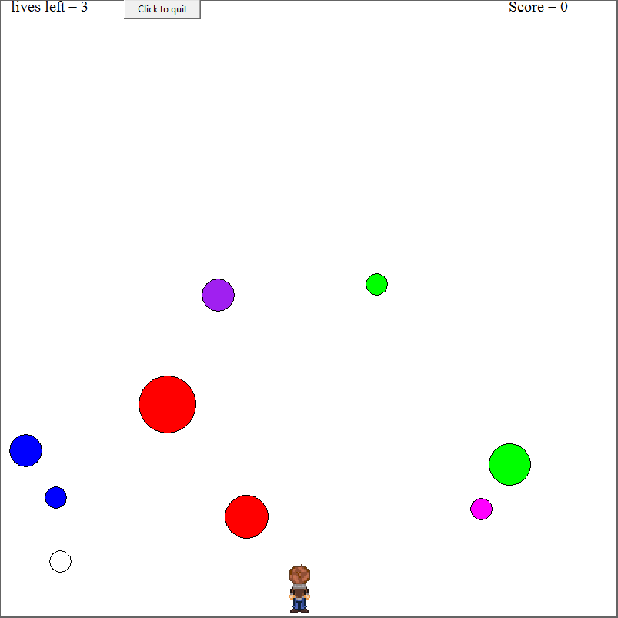

# Instructions for play

To open the game, open the Python file **BubbleTrouble.py** and push F5.

The game screen will start off with your character in the middle of the screen and various sized bubbles at the top of the screen. These bubbles will start to fall

To move your character, use the arrow keys ( i.e left arrow key to move left and right arrow key to move right). To fire your harpoon gun, press the space bar once.

After you have cleared the screen of all bubbles, the game will congratulate you and quit. If you lose all of your lives, the game will display a game over message and the game will quit. If you would like to quit on your own, press the “q” key on the keyboard or press the quit game button at the top of the screen.

# Pseudocode algorithm for the runGame() procedure

Def runGame():

Generate all initial variables:

**While** quitGame==False:

UpdateadndrawPlayerPos()

UpdateanddrawBallPos()

UpdateanddrawScore()

Updateanddrawlives()

If fire ==True:

Fireharpoon()

if lives==0:

display “game over” message

quitGame==True

if score==(some number that indicates all bubbles have been burst):

display “You Won!” message

quitGame==True

screen.update()

sleep(0.01)

deleteImages()

stopgame()